**Lab 3**

Jiho Kim, Garth Slaney

ENSF 480

Submission Date: October 8, 2020

University of Calgary

**Exercise A output**

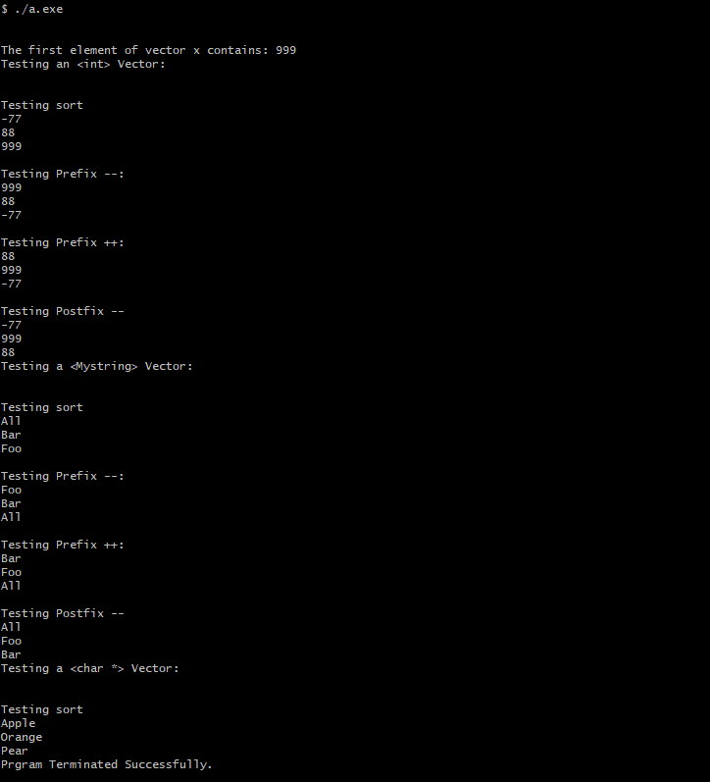

**Exercise B output**

